**Quarter-to-date total**

The quarter to date aggregates data from the **first month of the fiscal quarter.**

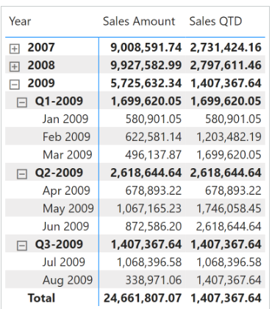

The quarter-to-date total of a measure is computed with the technique used for the year-to-date total. The only difference is that the filter is now on Year Quarter Number instead of Year:

Sales QTD :=

VAR LastMonthAvailable = MAX ( 'Date'[Year Month Number] )

VAR LastYearQuarterAvailable = MAX ( 'Date'[Year Quarter Number] )

VAR Result =

    CALCULATE (

        [Sales Amount],

        REMOVEFILTERS ( 'Date' ),

        'Date'[Year Month Number] <= LastMonthAvailable,

        'Date'[Year Quarter Number] = LastYearQuarterAvailable

    )

RETURN

    Result

The quarter to date aggregates data from the **first day of the quarter,** as shown in Figure

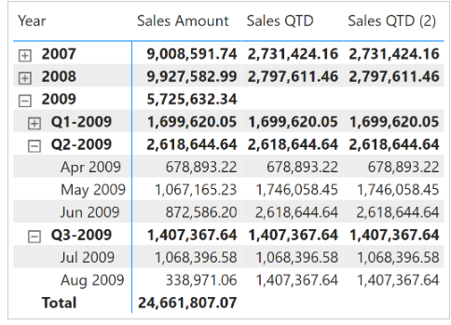

The quarter-to-date total of a measure is computed with the [**DATESQTD**](https://dax.guide/datesqtd/?aff=dax-patterns) function as follows:

Sales QTD :=

IF (

    [ShowValueForDates],

    CALCULATE (

        [Sales Amount],

        DATESQTD ( 'Date'[Date] )

    )

)

The [**TOTALQTD**](https://dax.guide/totalqtd/?aff=dax-patterns) is a possible alternative to [**DATESQTD**](https://dax.guide/datesqtd/?aff=dax-patterns):

Sales QTD (2) :=

IF (

    [ShowValueForDates],

    TOTALQTD (

        [Sales Amount],

        'Date'[Date]

    )

)